Explorations in

Physics

An Activity-Based Approach to Understanding the World





David P. Jackson
Dickinson College

Priscilla W. Laws
Dickinson College

Scott V. Franklin
Rochester Institute of Technology

With Contributing Author:
Kerry P. Browne
Dickinson College

John Wiley & Sons, Inc.


Names (and optionally, a picture) of partners

Explorations in Physics by David Jackson, Priscilla Laws and Scott Franklin is licensed under the Creative Commons Attribution-ShareAlike 3.0 Unported License. To view a copy of this license, visit http://creativecommons.org/licenses/by-sa/3.0/.

UNIT C
Heat, Temperature, and Cloud Formation Detailed Contents

Objectives C-1

OVERVIEW ................................................................... C-2
- EXPERIMENTING AND HYPOTHESIZING ....................................... C-5
  - THERMOMETERS AND TEMPERATURES .......................................... C-5

MIXING WATER............................................................... C-9
- THE DISTINCTION BETWEEN HEAT AND TEMPERATURE . . . . . . . . . . . . . . . . . . . . . . C-17
  - GASES, LIQUIDS, AND SOLIDS ................................................ C-17
  - TURNING UP THE HEAT...................................................... C-22

Thermal Energy Transfer and Temperature Changes..................... C-29
  - SPECIFIC HEAT............................................................. C-34
- EVAPORATION, CONDENSATION, AND HUMIDITY . . . . . . . . . . . . . . . . . . . . . . . . . . . . . C-39
  - HEAT OF TRANSFORMATION ................................................. C-39

EVAPORATION.............................................................. C-45
  - RELATIVE HUMIDITY AND DYNAMIC EQUILIBRIUM.............................. C-48

CLOUD FORMATION . . . . . . . . . . . . . . . . . . . . . . . . . . . . . . . . . . . . . . . . . . . . . . . . . . . . . . . . . C-55
  - GAS COOLING AND DEW POINT .............................................. C-55
  - UNDERSTANDING CLOUD FORMATION ........................................ C-59
  - MAKING A CLOUD .......................................................... C-62

PROJECT IDEAS . . . . . . . . . . . . . . . . . . . . . . . . . . . . . . . . . . . . . . . . . . . . . . . . . . . . . . . . . . . . . C-69
  - SALTING ROADS AND MAKING ICE CREAM ..................................... C-70
  - WHEN DOES COFFEE COOL THE FASTEST?. . . . . . . . . . . . . . . . . . . . . . . . . . . . . . . . . . . . C-71
  - WINTER CLOTHING, INSULATION AND LAYERING ............................... C-72

Wind Chill, Apparent Temperature, and Hypothermia .................... C-73
  - EVAPORATION RATE ........................................................ C-74
  - TEMPERATURE AND HUMIDITY VARIATIONS.................................... C-75
  - THE DENSITY OF FOG ....................................................... C-76

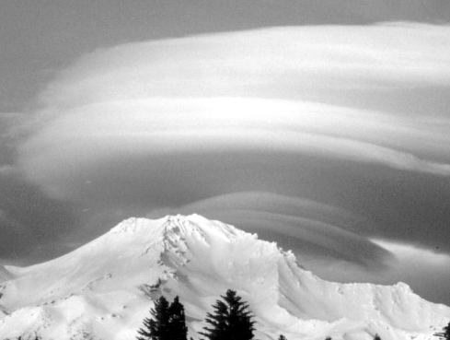
Heat, Temperature, and Cloud Formation C-1

UNIT C
Heat, Temperature, and Cloud Formation

Nature, it seems, is the popular name For milliards and milliards and milliards Oƒ partiCles playing their inƒinite game Oƒ billiards and billiards and billiards.
--Piet Hein
0 Objectives

- To observe and describe temperature differences and compare these with our sensations of hot and cold.
- To understand why a thermometer behaves the way it does and to understand the relationship between different temperature scales by constructing our own thermometer.
- To develop a model for how thermal energy is transferred between objects and to understand how the transfer of thermal energy causes the temperatures of objects to change.
- To build an understanding of phase changes of matter, such as the melting of ice and the boiling of water.
- To recognize the difference between wet-bulb and dry-bulb temperature readings and understand how this difference provides a measure of humidity.
- To use the concepts of evaporation, condensation, and relative humidity to understand the principles of cloud formation and investigate the conditions under which clouds will form.
- To learn more about the nature of heat, temperature, and the process of scientific research by undertaking an independent investigation.

C-2 Explorations in Physics

0.1 Overview

Everyday we engage in activities that are influenced by heat and temperature from drinking a glass of iced tea to feeling chilled after swimming on a hot day to stepping through a fogged bathroom after a hot shower. Even so, we rarely think carefully about the concepts of heat and temperature and how they affect our daily lives. If you want to cool down a glass of tea, how much ice do you need to add? If you add two ice cubes, will it cool the tea down twice as much as if you added only one ice cube? How much will drinking the iced tea actually cool your body. Why do you get chilled after swimming even on a hot day? What makes the temperature you “feel” seem different even if the actual temperature hasn't changed? Why does fog form in your bathroom when you take a hot shower? Will opening the window in your bathroom prevent the fog from forming or make it worse? In this unit, we will investigate the concepts of heat, temperature and humidity with the aim of learning how to answer these kinds of questions.
In addition, you will learn how these concepts fit together to explain other everyday phenomena. In the process, you will have an opportunity to work on experiments to help you understand the nature of these concepts. In the end, you will even make your own cloud. Some of your work will be done independently and some in small teams. You will likely learn the most when you are engaged in discussions with your partners. Debating your ideas will lead all of you to a more solid understanding of the concepts under study. So don't blindly work through the experiments. If you don't understand something, speak up and challenge your partners to explain it to you. The ensuing discussion will benefit you all.
The path that we will be taking in this unit is a bit complicated so it is useful to break it down into smaller, more manageable pieces. First we will look at temperature and how we measure it. Then we will investigate how two objects of different temperatures interact. Next we will study how a substance, in our case water, changes form as it is heated. This kind of transformation is known as a phase Change. Finally, we will tie all of this together to explain one of the most ephemeral of phenomena, the cloud. This is all summarized in Figure C-1.

40
30
20
10
0
–10
–20
–30
120


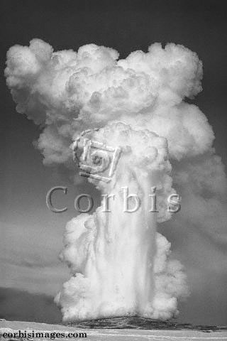
100
80
60
40
20
0
–20

C F

Sections 1 & 2: How does a thermometer work?

Sections 2 & 3: How are “heat” and temperature related?

"Simon Fraser
/Photo Researchers
Sections 3 & 4: How are evaporation and humidity related?

"Corbis Images

Section 4: What makes a cloud form?

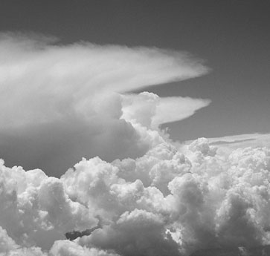
Figure C-1: The main questions we will be tackling in this unit.

As we carry out our investigations, it helps to have some specific questions we would like answered. As already mentioned, we all know when something is “hot,” but this doesn't describe things specifically enough to be useful. A natural first question might be how does a thermometer work and what does it tell us? As you know, you can increase the temperature of an object by “heating it up” (in an oven, for example). But how that happens may be a bit of a mystery. Therefore, another question is how does heating something up produCe a temperature Change? A third common experience for most

Heat, Temperature, and Cloud Formation C-3

people is the boiling of water. Water naturally “evaporates” into the air, but when we boil it, evaporation is more rapid. What exactly is taking place and does this extra water in the air have anything to do with humidity? A third question might be how are evaporation and humidity related? Finally, as you watch a pot of water boil you see “steam” rising into the air (some of you may even be familiar with the “steam” rising from geysers and hot springs). This looks vaguely like fog or a cloud. So a final question might be what exaCtly is this “steam” and is it the same as a Cloud?
Since each of these smaller pieces builds on the previous one, it is important for you to have a solid understanding of each one before moving on to the next. This is important, and if you feel as though you do not quite understand something, talk to your instructor. You may find it useful to refer back to Figure C-1 on occasion, to see where we are and where we are going. This is particularly useful if you are having difficulty with a particular concept and you find yourself getting frustrated and bogged down on small details.
Paul notes:
In some of what follows you’ll be asked to make some guesses about what might be going on to explain how heat is transferred from one object to another. The authors of this exploration are assuming that you’re somewhat familiar with some of the concepts typically taught in a U.S. middle school science curriculum about temperature and heat. These include the ideas that:
- Matter is made of atoms (think of them as balls)
- The balls are attracted to each other. In a solid the attraction between the atoms are called atomic bonds, and it’s as if the balls are connected to their neighbors by springs, and they always have the same neighbors. In a liquid, or a gas, the attraction is less (compared to their speed) so that the atoms can slip past each other and they don’t always have the same neighbors.
- Temperature is related to the speed at which the atoms are moving. In any collection of atoms, the faster the average speed of the atoms, the higher the temperature. (Absolute zero, which is a temperature of -273.15 Celsius, for classical systems of atoms, is the temperature at which all the atoms are stopped.)
- It would be useful to review some of these ideas in pictures. This web page from the ACS (American Chemical Society) attempts to illustrate what happens at the atomic level when a cold spoon is put in contact with hot soup. Or when a hot spoon is put into a cold glass of water:
See: tiny.cc/ACStemperature .

C-4 Explorations in Physics

Heat, Temperature, and Cloud Formation C-5
1 Experimenting and Hypothesizing

We begin this unit by looking at something we are all familiar with—thermometers. As you know, thermometers are used to determine the temperature of an object. What you may not be aware of is that thermometers do not always give a correct reading for the temperature of an object. Thus, we will begin by learning how to make an accurate measurement of temperature with a thermometer. After that, we will explore how the temperature of a glass of water changes when it is mixed with water of a different temperature. In particular, we will devise a method to determine the final temperature of the mixture after we combine a cup of hot water with a cup of cold water.
You may need some of the following equipment for the activities in this section:
- Thermometers and temperature sensors [1.1, 1.2]
- ~500 ml beakers [1.1, 1.2]
- ~100 ml graduated cylinders [1.1, 1.2]
- Styrofoam cups [1.1, 1.2]
- Hot and cold water [1.1, 1.2]
- MBL system [1.1, 1.2]

Thermometers and Temperatures

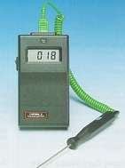
Why does it take so long to take your temperature with an old-fashioned thermometer? What determines how long you must wait before the thermometer returns an accurate reading? You will be using thermometers in most of the activities in this unit. Therefore it makes sense to spend a few minutes investigating how they work.

Activity 1.1.1 Thermometers and Thermal Equilibrium

    - Use a “standard” thermometer to measure the temperature of the air in the room. Next, get a cup of hot water from the tap and while watching the temperature readings on the thermometer, place it in the cup of water. Describe what you observe.

a b

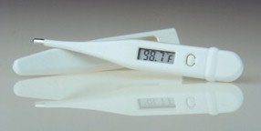

c
Figure C-2: Two types of thermometers: a A standard liquid-filled thermometer b and c Electronic-thermometers. (a and c courtesy of Pocket Nurse Enterprises, Inc. b courtesy of Electronic Temperature Instruments, Ltd.)

    - Is the thermometer making an accurate reading of the temperature of the water from the moment it is placed in the cup? How long do you think the thermometer needs to sit in the water before it is reading an accurate temperature?

C-6 Explorations in Physics

    - If the thermometer is not making an accurate reading of the water when it is first placed in the water, what temperature do you think it is measuring?

    - Now take the thermometer out of the water and let it sit in the room air. Again, watch the temperature readings and describe what you observe. How long do you think the thermometer needs to sit in the air before it is reading an accurate temperature? Why do you think this is so different from the time it needs to sit in the water?
A related question: In which case (in air or in water) do you think the surrounding molecules are bouncing off of the thermometer more often?



There is a subtle lesson to be learned here. Before the thermometer is placed in the water, it is at the same temperature as the air. Once it is placed in the water, its temperature increases because it is in contact with the warmer water. Once it has been sitting in the water for a while, the thermometer reaches the temperature of the water. We say that it is in thermal equilibrium with the water. Thus, we view this situation as follows. When two objects at different temperatures are in thermal contact with each other, their temperatures will change. This will continue until the objects have reached thermal equilibrium, at which point their temperatures are equal. As simple and obvious as this may sound, scientists use this type of reasoning to define the concept of temperature.

Using a Temperature Sensor
The previous activity can be made much more visual with the use of an MBL system and a temperature sensor. The computer can make many temperature readings and plot them on a graph. This will allow us to view how the temperature is changing with time. This kind of graph is called a temperature-time graph. A temperature-time graph can be much more useful than a large table of numbers because you can see very quickly how the temperature varies over time. Your instructor may provide you with more specific information on how to use the temperature sensor and MBL system.

See below




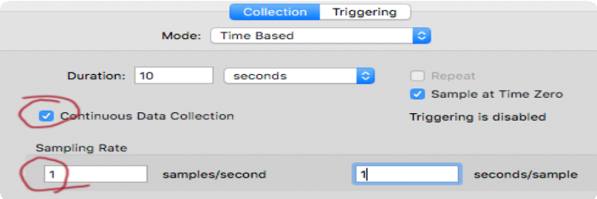

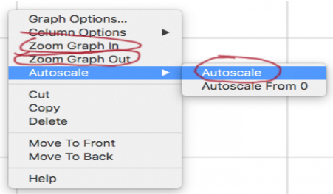
We'll be using "Logger Pro" on the PCs as our "MBL" (Microcomputer Based Laboratory) system. Here are some things to do to get going:
- Go to the Windows "Start" menu and type "Logger..." to start the program. When you start it up, you should see the temperature from the temperature probe already displayed. If not, check with your instructor.
- Click on this "Data Collection" icon: You'll see a menu like this:

- Check "Continuous Data Collection"
- Set the Sampling Rate to 1 sample per second

- Take a few seconds of data and examine it:
  - Click the "Start" button.
  - You should see temperature numbers showing up once per second in the spreadsheet area, and the graph will start to fill in.
  - You're taking data continuously (see above) so it won't stop collecting data until you hit the "Stop" button. Hit that button after at least 10 seconds.
  - If you right-click with your mouse on the graph you'll see this menu. The circled options let you zoom in (or out) to see more detail on your data.

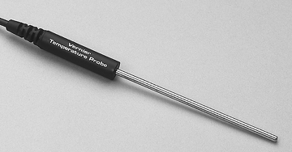
Heat, Temperature, and Cloud Formation C-7

Activity 1.1.2 Temperature Sensors

    - Imagine the following experiment. A temperature sensor has been sitting out in room air for a while. The sensor is then placed in a cup of hot water until it is in thermal equilibrium with the water. Then the temperature sensor is removed from the water and held in the air. Make a rough sketch of what you think the temperature-time graph will look like for this experiment. Briefly explain your prediction. Note: Make sure to indicate on your sketch the times at which the sensor is placed into the water and when it is removed from the water.

Figure C-3: Temperature sensor for use with computer based laboratory systems. (Courtesy Vernier Software and Technology)

      - Now, carry out the experiment. Set the software to run for 10 minutes and start the experiment after the sensor has been sitting in the air for quite a while. Then, after about 30 seconds, place the sensor in a cup of hot water. After the temperature no longer appears to be changing, take the sensor out of the water and let it sit in the air for the remainder of the experiment.
Either take a screenshot and paste it into this file, or, take a picture and insert the image file into this file.

Whichever you do, it’s best to add another page at this point to host the picture, and then you can make the picture as big as you need to in order to see lots of detail
C-8 Explorations in Physics

    - Is the behavior of the temperature sensor similar to that of the standard thermometer? Explain briefly

    - Describe how the graph looks when the temperature is changing rapidly compared to when it is changing more slowly.

It should be fairly obvious from the previous activity that thermal equilibrium is reached much more quickly when the temperature sensor is in water compared to when it is in air. It should also be pretty clear that the electronic temperature sensor behaves very much like a standard thermometer.

Accuracy oƒ the Temperature Sensor
The fact that an electronic temperature sensor behaves much like a standard thermometer does not mean that it should be trusted without a second thought. As we saw in Activity 1.1.1, even a standard thermometer will give an inaccurate reading if it is not in thermal equilibrium with the object whose temperature you are trying to measure. Furthermore, there is some inherent imprecision when making any measurement (not just temperature). In the next activity, we will look more closely at how precisely we can measure temperature with our temperature sensors.

Activity 1.1.3 What Temperature is it?

- Take a cup of cool water and place the temperature sensor in the water. After about 30 seconds, start the software while continuing to hold the temperature sensor in the water. Stop the software after 30 seconds and comment on the temperature-time graph.

Heat, Temperature, and Cloud Formation C-9

Right-click and choose "autoscale" or zoom in / out
On your graph:
Include a picture of your zoomed-in graph.
- Now, rescale your temperature graph so that until you can see the temperature going up and down, perhaps at a very fine scale say 0.5°C or 0.2°C overall range, or even smaller. Comment on what you observe.

- Based on your observations in part b), how much can you trust your temperature reading? Is it precise to within 1°C? To within 0.5°C? To within 0.1°C? Explain your reasoning.



As demonstrated in the previous activity, your temperature measurements will not be perfectly accurate. There will be some (we hope small) amount of uncertainty associated with any measurement process and it is wise to always keep this in mind. Knowing how much uncertainty is inherent in your measurements will help you determine when two measurements are the same. For example, if your temperature sensor is precise to within 0.5°C, and you measure the temperature of two cups of water to be T₁=22.3°C and T₂=23.6°C, you can be pretty sure that these temperatures are, in fact, different. If, on the other hand, you measure these temperatures to be, T₁=22.3°C and T₂=22.9°C, you cannot know for sure whether or not these two temperatures are different because they could each be wrong by as much as 0.5°C.
Most electronic temperature sensors are precise to within 0.5°C and many are precise to within 0.1°C (or even better). In this unit, we will not be interested in measuring temperature differences that are smaller than 1°C.

